**EN 001203 Computer Programming (Section 5)**

**Class website:** <https://sites.google.com/a/kku.ac.th/classes/cpg>

To learn problem-solving skills through computer programming.

**To do:**

* Download course slides. See class website (under class materials)

**Week 3:** Jan 3rd – 9th 2021

**Previously, we have learned:**

* Orientation and introduction, e.g., objectives, class assessment, textbooks

* Basic computer system, e.g., hardware, software, OS

* Basic software development paradigm, i.e., a computer program gets translated to a machine code by a compiler

* The tool we will use: C++

* Some terminologies

* directory/folder

* terminal window / command window

* prompt

* Some system commands

* dir

* cd

* mkdir

This week objectives are:

* Continue getting familiar with some more system commands

* how to create, delete, copy, move, and view a file

* data file vs executable file (program)

* relative path vs absolute path

* Hand on our first C++ program

* in a classic style

* with CodeBlocks

* Where to get reference on C++ language (beside Googling it, of course)

* Practice output programs

* Get to know Autolab

**1. Basic system commands**

**1.1. Recall how to get the terminal.**

1.1.1. Get the file explorer window open.

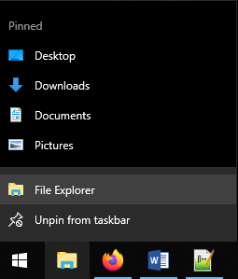

Once it is on, the file explorer window may look like the follows.

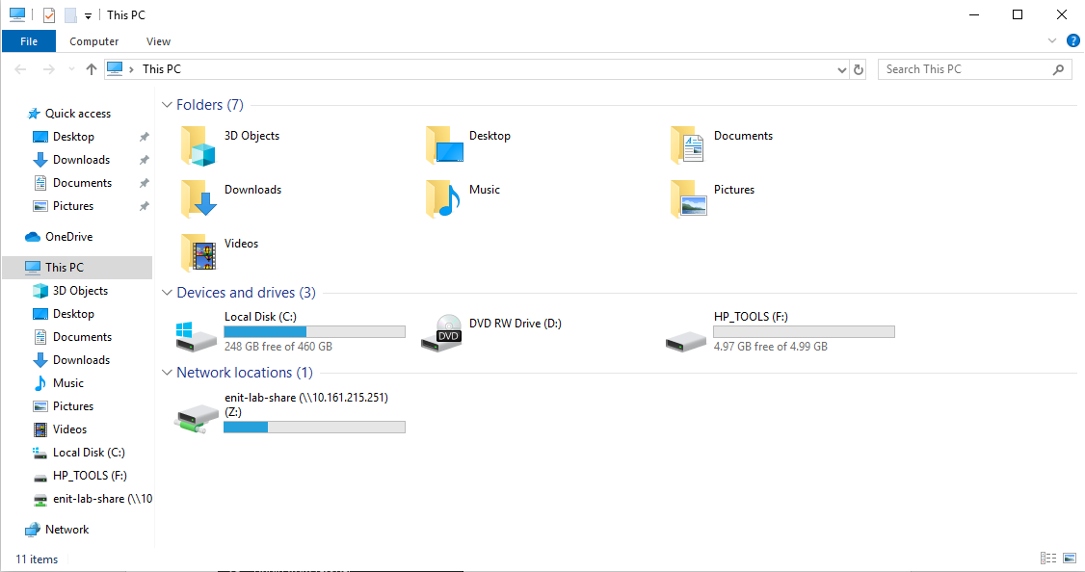

1.1.2 Click on the address bar.

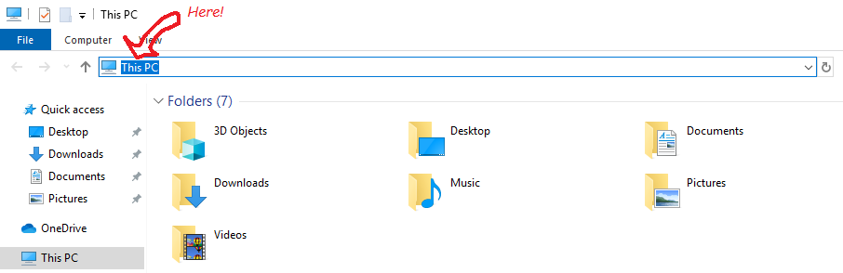

1.1.3 Type in cmd on the address bar and press <ENTER>. Note cmd is to activate cmd.exe program, which is to get the command window on.

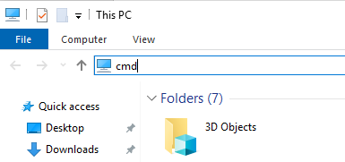-

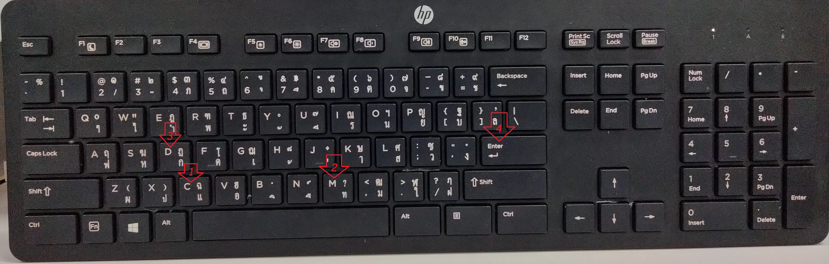

H

This is a very first time, so I show you this. Just in case. I won't do this every time.

Then, the terminal window gets open.

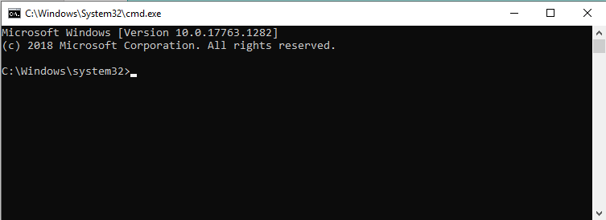

Good Job!!!

Now, we are at the C:\Windows\system32 location and ready to try out other system commands.

**1.2. Revise how change and create a folder.**

Objective:

(a) Create a folder named GetPrep at C:\

(b) Change the folder to be in C:\GetPrep.

Walkthrough:

1.2.1. Type cd /<ENTER> at the terminal.

(Notice that we have to press <ENTER> every time we finish the command. So, I may not be this detail next time.)

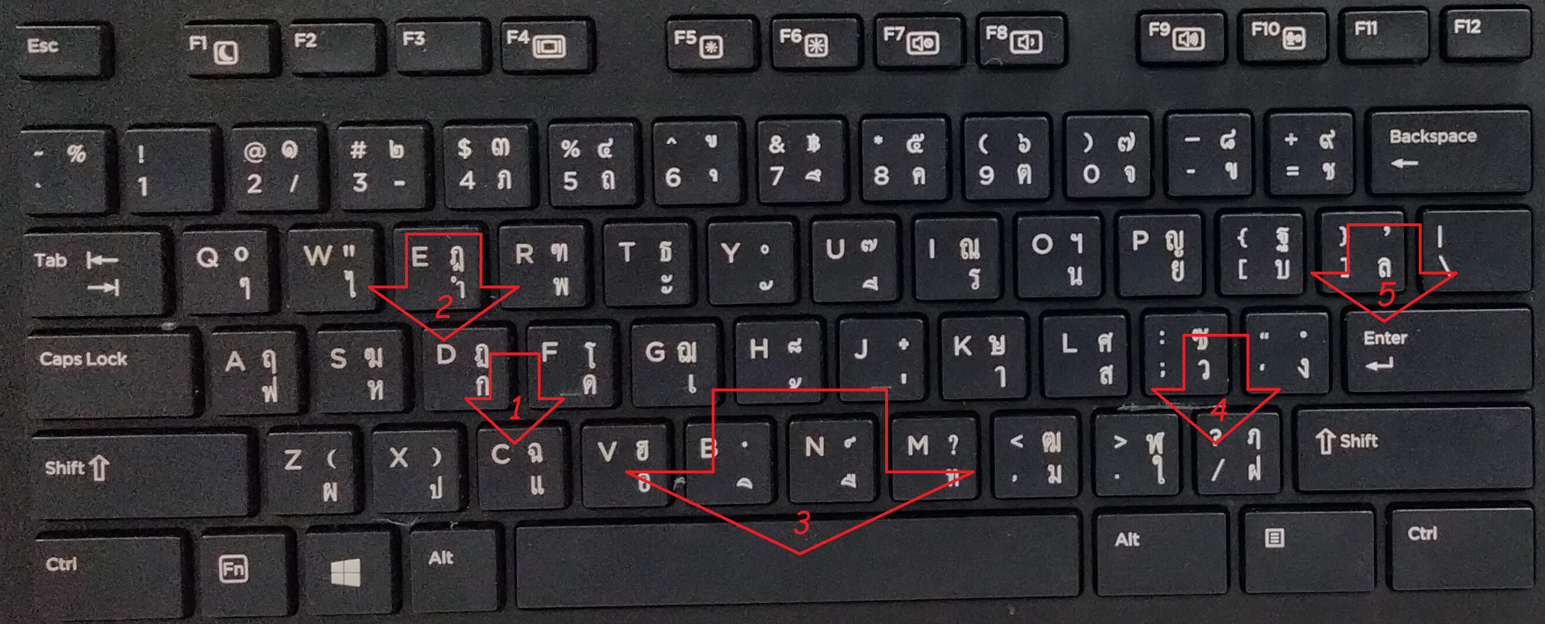

Just in case. I won't do this every time.

Once it is done, we will see something like the follows.

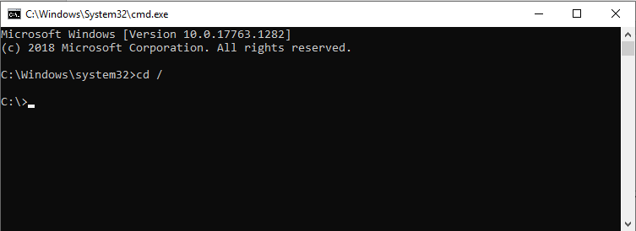

Now, we are at the root of C drive.

1.2.2. Create a folder GetPrep by typing in mkdir GetPrep

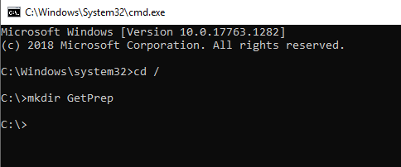

We do not see anything, until we ask for it.

Type in dir/w to see what inside C drive and we might see something like the follows.

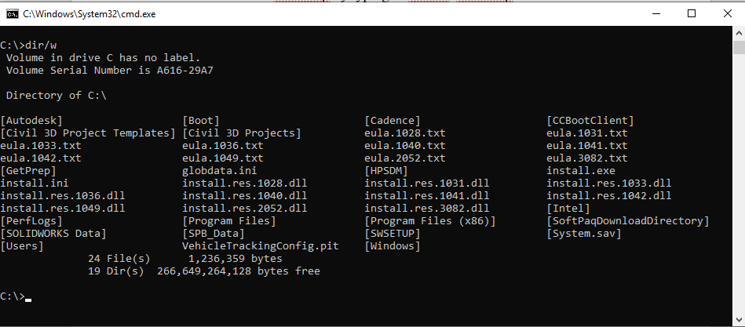

*There, it is!*

1.2.3. Go inside the GetPrep by typing cd GetPrep

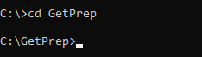

Now, we have C:\GetPrep and we are at the C:\GetPrep.

Mission accomplished.

1.2.4. Now, practice.

* Create a folder cprog in GetPrep

* Create a folder cpp in GetPrep

* Get inside the folder cprog

Here's a screenshot of what we might see.

Notice that we should have checked if two folders are actually created. (by dir/w)

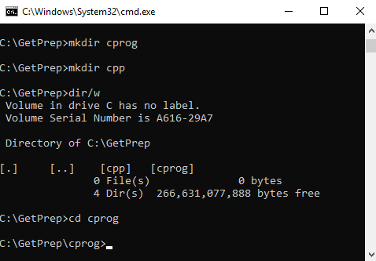

Good! They are really there.

To see what has been done

**1.3. How to create and view a file**

"A file is like a meat, while a folder is like a bowl."

We have learned how to create and navigate folders. Now, we will learn a bit about how to create, view, and delete files.

There are many ways to create a file.

One of the simplest may be using pipe.

1.3.1. Create a text file by echo and redirection.

1.3.1.1 Type echo I am learning something good.

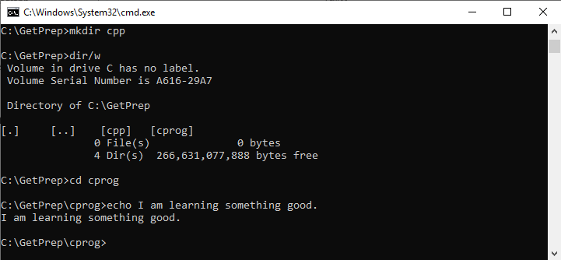

What echo does is just to print out what comes after to the screen.

1.3.1.2 Type echo I am learning something good. > note.txt

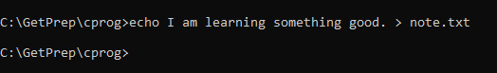

This time, nothing shows up (on screen).

But, we can dir/w to see.

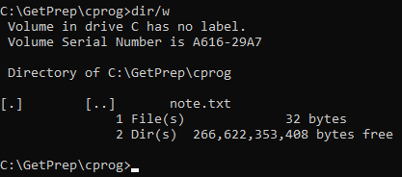

There is a file named note.txt created.

What > does is redirecting the output from echo to a file, which we specify its name as note.txt.

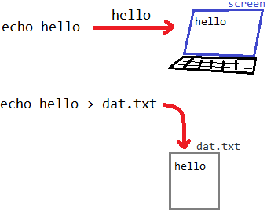

1.3.2. To see content of the file, we do type *<filename>*. In this case, we do type note.txt

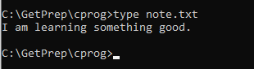

While dir/w is to see what inside the folder, type is to see what inside the file.

Well Done!!!

1.3.3. Now, practice the follows.

* Create a file named hello.txt with content Hello, Covid

* Create a file named meet.txt with content We will meet on zoom

* Create a file named week3.txt with content basic system commands

Once you are done, check the outcomes.

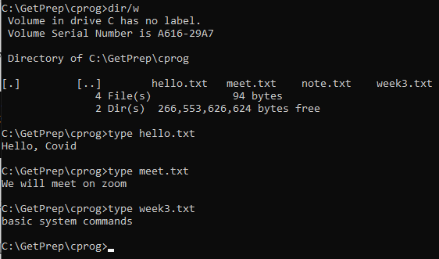

All contents look good.

hello.txt, meet.txt, and week3.txt are all here. Good!

**1.4. Data file vs executable file (program)**

In Section 1.3, we have seen the data files, e.g., hello.txt, meet.txt, note.txt, and week3.txt. We use a data file by reading its content, but we cannot command a computer through a data file (at least, not directly).

There are some files that we can command a computer through them.

1.4.1. Type explorer on the terminal.

Notice what has happened.

Programs that are available in the computer can be run by calling its name.

1.4.2. Try calling the following commands. (Try one at a time, so you have time to digest what is going on.)

* start chrome

* notepad

* "c:\Program Files (x86)\CodeBlocks"\CbLauncher

Notice what have happened.

If some of them do not work, that's fine. It may be because the program has not yet been installed (or set up "properly") in the computer.

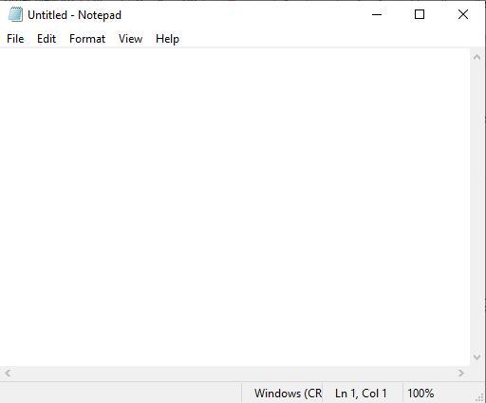

Figure Notepad

Notepad is a Text-Editor program. Text editor allows us to create and edit a text file. Put it simply, a text file is a data file, whose data is text.

Try notepad: type in something, save, open other text file, edit, save, play around for a bit.

Practice:

(1) Using Notepad, write your name in student.txt and saved the file in C:\GetPrep\cpp.

(2) Using Notepad, write your best quality (trait that you are most proud of) in quality.txt and saved the file in C:\GetPrep\cprog.

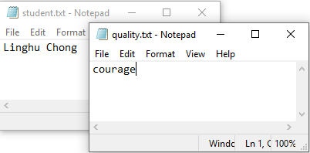

Figure Practice using Notepad. Put student.txt under folder cpp and quality.txt under cprog.

CodeBlocks is a Integrated Development Environment (IDE) program. IDE provides a fancy text editor and other handy tools to make writing and testing a program easier. We will come back to CodeBlocks later. It is a recommended IDE for our class. But, leave it for now.

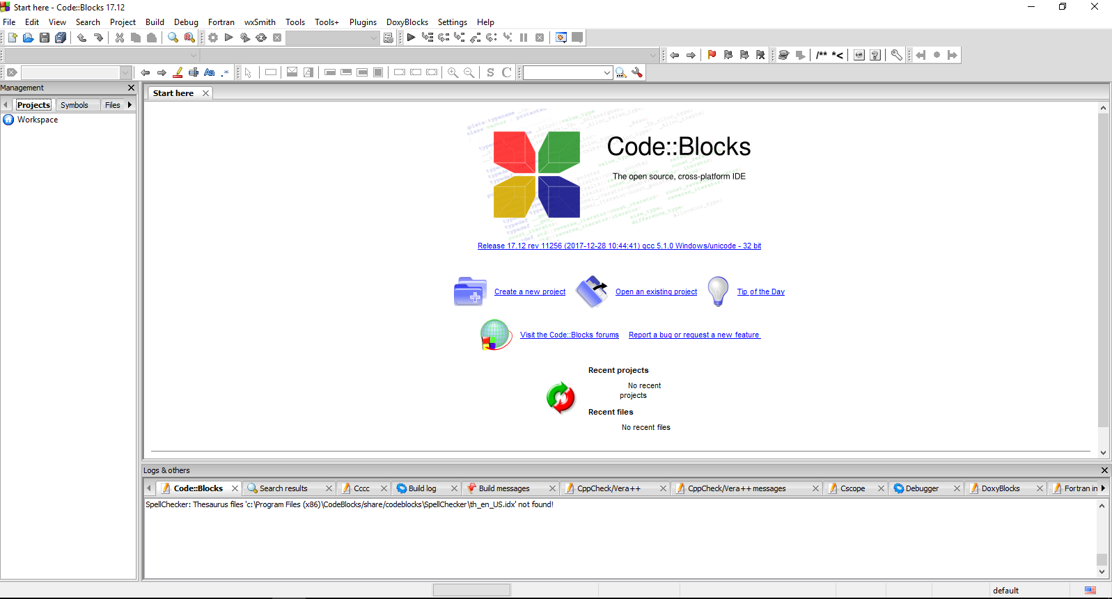

Figure CodeBlocks (recommended IDE for this class)

Data file is a plain text. We can use a notepad to create it. But, a program file is more complicated. We have to write a program and compile it to make it an executable file, which we will have our hands on in Section 2.

**1.5. Relative path vs absolute path**

When referring to a file, it is better to specify its path (where to find it). There are two ways to specify a path: relative path and absolute path.

Objective

* Using system commands to type out the contents of student.txt and quality.txt from C:, C:\GetPrep, C:\GetPrep\cpp, and C:\GetPrep\cprog.

*1.5.1. Using an absolute path*

At the terminal, do it at C: as shown in the picture.

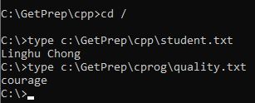

Do it at C:\GetPrep as shown in the picture.

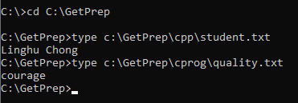

Do it at C:\GetPrep\cpp as shown in the picture.

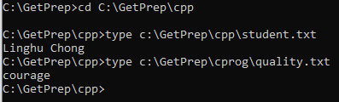

Do it at C:\GetPrep\cprog as shown in the picture.

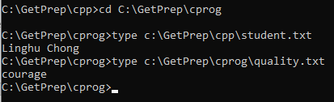

*1.5.2 Using a relative path*

Do it at C: as shown in the picture.

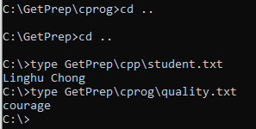

Notice that .. means back one step. How many times we do depends on how many steps we need to go back up.

Do it at C:\GetPrep as shown in the picture.

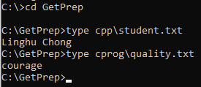

Do it at C:\GetPrep\cpp as shown in the picture.

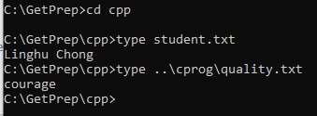

Notice that here, at cpp, it is easy to access student.txt.

But, to get to quality.txt, we need to go back up one step, then through cprog. See a structure of the file system below.

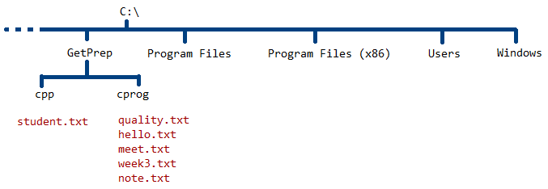

Do it at C:\GetPrep\cprog as shown in the picture.

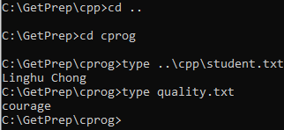

Notice here at cprog, we can access quality.txt directly, but needs to go back and through cpp to get to student.txt.



We are here (@cprog). To get to student.txt, go back up and down through cpp.

**Exercises**

E1.1. Using system commands to type out the contents of hello.txt from C: and C:\GetPrep\cpp by absolute path

E1.2. Using system commands to type out the contents of hello.txt from C: and C:\GetPrep\cpp by relative path

**2. Hand on our first C++ program**

**! Make sure that we have the compiler (GNU G++) and the IDE---CodeBlocks installed.**

**2.1. Compile and run in a classic style**

2.1.1. Write our first C++ program.

2.1.1.1. Use Notepad to write the following code.

#include <iostream>

int main(){

std::cout << "Hello, World++";

}

2.1.1.2. Save it as helloworld.cpp, as shown in the picture.

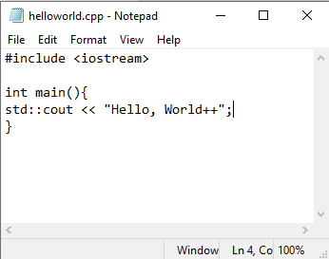

{ } Curly brackets are here, next to P button. You need <SHIFT>.

# (pound sign/sharp/hash tag) is here, on the 3 button. Press <SHIFT> + 3.

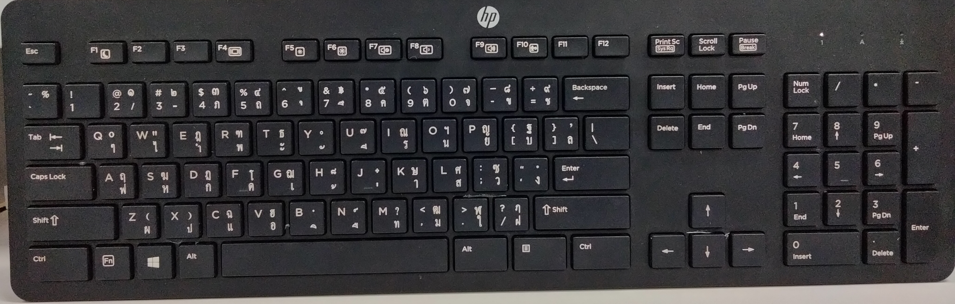

: (colon) and ; (semi-colon) are here, next to L. Press <SHIFT> to get colon.

2.1.2. Compile the program.  
At C:\GetPrep\cpp on the terminal, type

g++ helloworld.cpp -o helloworld.exe

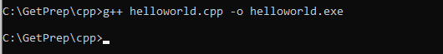

If it does not work, it may be either compiler is not installed or the path is not set properly.

2.1.3. Run the program.

It is like other regular executable files. Call its name to run it.

Type helloworld

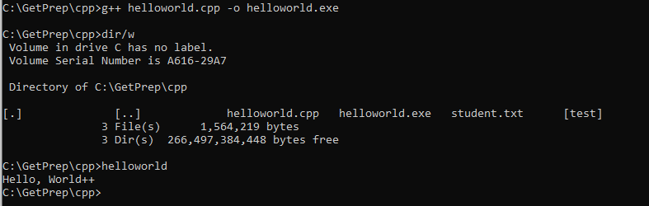

(4) See the program output.

(3) To run, call its name.

(2) After compilation, we get the executable file (machine code).

(1) This compiles helloworld.cpp to helloworld.exe.

Mission accomplished.

**2.2. Compile and run with CodeBlocks**

Dummy

Well Done!!!

**3. Recommended reference on C++ language**

To learn more about C++ language, including syntax, reserved words, available functions, libraries, and what libraries provide, check out

https://en.cppreference.com/w/

**Exercises**

E3.1. Which ones of the following terms are keywords in C++?

Terms to check: return, exit, char, character, false, fake, for, to, if, whether, int, integer, long, short, not, sizeof, weightof, switch, plug, true, real, float, sink, try, attempt, while, and when.

[Hint: check under keywords.]

E3.2. Which ones of the following terms are C++ Standard Library headers?

Terms to check: <cstdlib>, <cspecial>, <ctime>, <cplace>, <memory>, <climits>, <exception>, <outstanding>, <cstring>, <crope>, <array>, <cmath>, <cphysics>, <random>, <numbers>, <locale>, <iostream> and <cstdio>.

[Hint: check under headers.]

E3.3. Which ones of the following terms are functions in the standard library <cstring>?

Terms to check: strcpy, strcopy, strdog, strcat, strlen, and strcmp.

[Hint: see <cstring> under headers.]

4. Practice output programs

Good Job!!!

5. Get to know Autolab

5.1 Log in Autolab

Well Done!!!

5.2 Submit the answers

Mission accomplished.